**Exhibit A**

**CUSTOMER / Active Cyber REQUIREMENTS**

|  |  |
| --- | --- |
| **Name:** | **Rashid Noor** |
| **Title:** | **AD SME** |
| **PERSONAL INFORMATION** |  |
|  |  |
| **Home Street Address (no P.O. Box #’s):** | **India** |
| **Home City, State, Zip Code** |  |
| **Telephone Numbers** |  |
| **Home:** |  |
| **Office:** |  |
| **Cell:** | **+91 9711596255** |
| **Pager:** |  |
| **Personal e-mail address:** | **Rashid.Noor87@gmail.com** |
| **EMERGENCY CONTACT** |  |
| **#1 CONTACT** |  |
| **Name/Relationship:** |  |
| **Home Street Address (no P.O. Box #’s):** |  |
| **Home City, State, Zip:** |  |
| **Telephone Numbers** |  |
| **Home:** |  |
| **Work:** |  |
| **Cell:** |  |
| **#2 CONTACT** |  |
| **Name/Relationship:** |  |
| **Home Street Address (no P.O. Box #’s):** |  |
| **Home City, State, Zip:** |  |
| **Telephone Numbers** |  |
| **Home:** |  |
| **Work:** |  |
| **Cell:** |  |

**Appendix A**

**Non-Compete/Non-Solicit**

I, _**Rashid Noor**_, Vendor’s Employee, hereby agree that during the period of engagement and for one (1) years thereafter, I shall not, directly or indirectly (without prior written consent of Active Cyber, LLC (the “Company”)), (a) induce, or attempt to induce, any employee of the Company to quit Company’s employment. (b) recruit or hire away any employee of Company, (c) induce, or attempt to induce, any independent contractor who performed services for Company Clients to terminate the business relationship with the Client, (d) induce Clients or prospective Clients of Company that I become aware of to terminate, cancel, modify, reduce or discontinue business with Company. For the purposes of this Section, the term “contact” means interaction between the client I performed services for and I which takes place to further the business relationship, or making (or assisting or supervising the making of) sales to or performing or providing (or assisting or supervising the performance or provision of) services, products or projects for the client or prospective client on behalf of the Company. For purposes of this Section, the term “contact” with respect to a “prospective” Client also means interaction between I and a potential client of the Company which takes place to obtain the business of the potential client on behalf of the Company.

Acknowledged and agreed to:

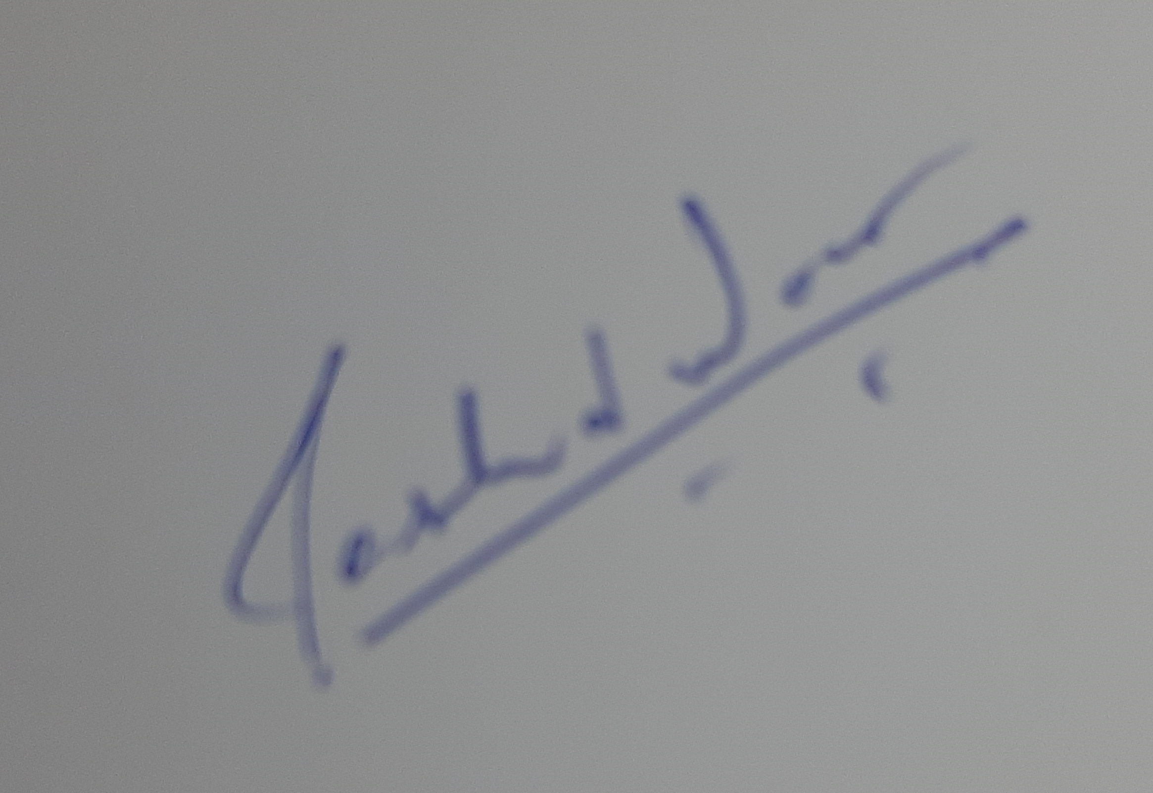

Signature

Rashid Noor

Print Name